Mark Cooney (Philip Turner X17114616)

MCVT IT Manager Recommendation

As the IT Manager I think we should enhance our website by adding an online cloud payment service. Not only would we have the store, but if we make the website better, it moves with the future and potentially opens the business to more customers.

There are some advantages and disadvantages of moving to the cloud. Firstly, our files can be accessed from anywhere you have an internet connection that can be good and bad. Secondly, our files would not be saved on the shop server, which means if anything ever happens to the office our data will not be lost. The cloud server would be our disaster recovery. With small business and cloud providers there is a chance your data could be saved on the same drives as other companies. Using cloud services can be cheaper than running our own server. With the files being stored in the cloud, bandwith will come into question. Will we have to upgrade the broadband in the store and will the cloud provider have enough bandwith for all of their customers. Also cloud services are usually not OS dependent, which means you can use either windows or apple mac machines.

After looking over a number of online payment services and evaluating them for the services they provide.

I think going forward having a product that could receive payments not only online from clients purchasing products with a credit card, but could receive payments through invoices or even online payments like PayPal. Also if in store transactions could be managed it would also be very useful. We would also need to make sure that there is security behind the payment service so that customers should not have to worry about the likes of their personal details being lost or stolen.

After talking to providers and some research online, looking at products like Sage Pay, PayPal business, Google wallet and Amazon Pay.

PayPal provides payments for users with or without a PayPal account and customers can also provide invoices.

Amazon Pay only offers an option for online payments

Google wallet provides payment services for online and in store transactions

SagePay seems to provide the best options for the store, website, staff and clients.

Face to Face and over the Phone

With options for accepting the payments face to face which means we can accept chip and pin payments in the store and over the phone with sage also providing the device for the payments.

Online Payments

Online payments can be made with credits cards and also accepts PayPal for those users who want extra security.

Invoice Payments

SagePay can also accept payments for invoices. This service can help reduce late payments.

Fraud Prevention

SagePay has free tools to help prevent against fraud. There are two levels for this, the Sage services and then the Sage services with ReD worldwide who are a specialist provider in fraud prevention. Sage will help us setup the fully customizable fraud prevention rules, with address verification and CV2 checks in real time. Secure authentication with visa and MasterCard.

On top of Sage services there is the Bespoke fraud services with ReD Worldwide. Transactions will be screened against their global database with millions of entries and quarterly reviews of your screening rules.

Reports

Sage support team can prepare a number of customized reports on a daily, weekly or monthly basis to best suit our needs.

Cost

Sage have different cost for each component.

The Online payments have the range from €20 a month upwards

The flex plan allows for 350 online transactions, free fraud screening and 24/7 phone and email support.

The next plan Plus allows for more transactions, more fraud prevention services and are able to accept other European payment types at a cost of €45 per month.

The Corporate plan is the top service and can be customized to our needs and then your cost would be depending on them needs.

Invoice payments range from €5 to €15 a month again depending on our needs. The extra service has cheaper credit card and transaction charges which could look better with clients.

Phone payments another cost at €15 per month and up depending on the plan.

Conclusion

With the services that SagePay can provide and the potential integration with other sage packages like sage accounts packages, I think this product could make a great addition to company. With easy use many great services as described already and reasonable cost it could leave money to improve the company elsewhere as well.

User Guide

## Logging into MySagePay

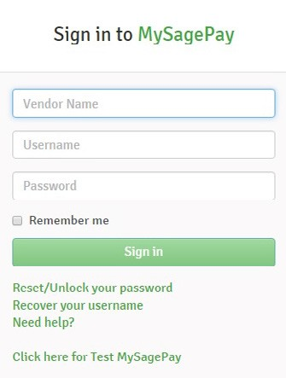

The first thing you will need to do before you can use your MySagePay is to log in.

To do this you must go to the MySagePay login page.

The URLs that you will need to enter into your browsers for

MySagePay are –

**TEST Server**

https://testportal.sagepay.com/mysagepay/login.msp

**LIVE Server**

https://portal.sagepay.com/mysagepay/login.msp

After reaching the login page you will be able to enter your details and login to your account.

The My Account section allows you to change the details of the user currently logged into the account as.

You are able to create a new password for this user, and add an e-mail address to the user so you can receive updates and communications from Sage Pay.

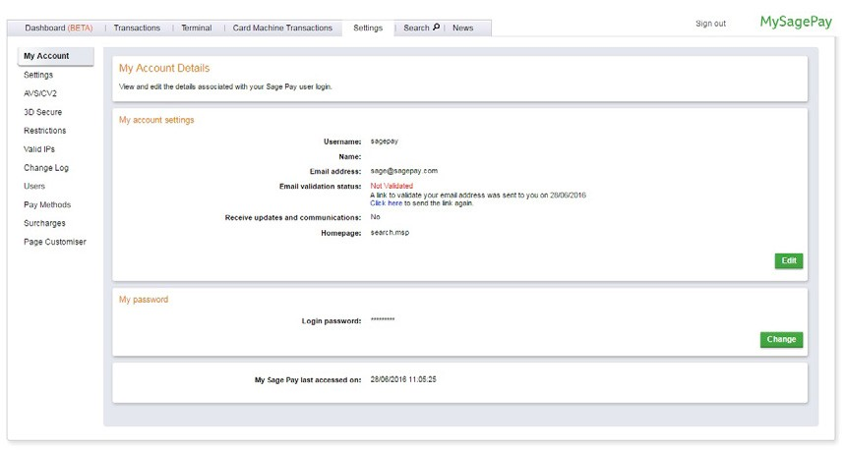

If you are logged in as the administrative user, you are not able to change the password.

You can only change passwords for users that you have created, not the Administrator set-up by Sage Pay.

The Settings enable you to change the details of your account and apply certain restrictions. You have four options in this section –

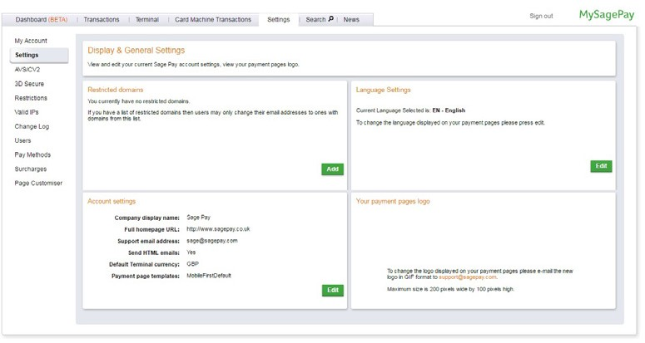

**Restricted Domains**

This is where you are able to add specific e-mail domains to your account that once applied force users to have e-mail addresses that use the domains listed.

For example – if you add sagepay.com to the list users can only change their email addresses to

###### [name@sagepay.com](mailto:name@sagepay.com)

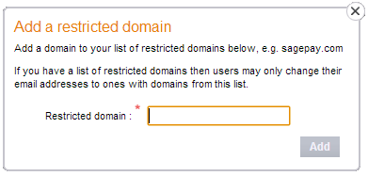

This section allows you to change the details for your company that are displayed to your customers, and included in your confirmation emails if sent from Sage Pay.

You are able to change your company display name, your homepage URL, and your support e-mail address.

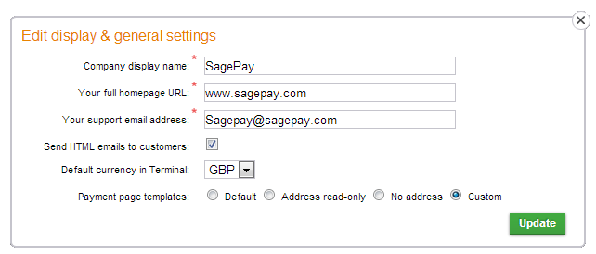

Also if you have telephone payments enabled on your account you are able to change the default currency.

Alongside this you can also activate your customized payment pages here. If we have added your customized payment pages to your account, you are able to switch them on in this section.

**Payment Pages logo**

If you have provided Sage Pay with your company logo it will be displayed to you here. This is the logo that will appear on your Sage Pay payment pages.

## AVS/CV2

AVS (Address Verification System) and CV2 (Card Verification checks) are two of the fraud prevention tools that are available to you when you have an account with Sage Pay.

The AVS fraud prevention tool checks the numerical values in the customer’s address and postcode against the details that are held with the card issuing bank to ensure they match. The CV2 uses the three-digit security code on the reverse of the card to ensure it matches with the card details that are provided.

In this section you are able to turn the AVS and CV2 fraud prevention checks on, and once turned on you are able to apply rules to the account.

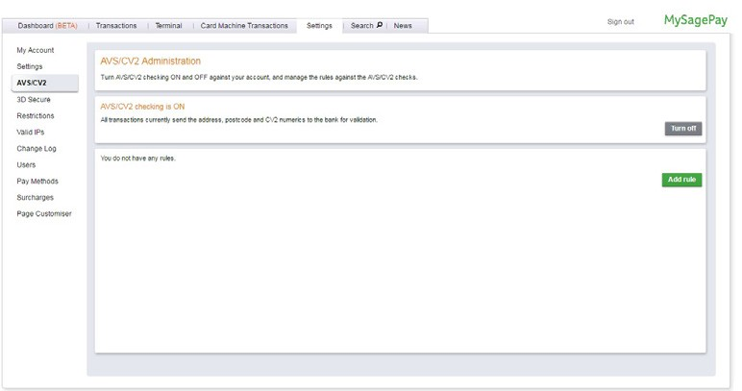

**Adding a rule**

These rules allow you to define how the results of your AVS and CV2 checks will be used by the Sage Pay systems.

From only performing the checks to rejecting transactions based on the results you can decide what you want to do with the transactions based on the results returned.

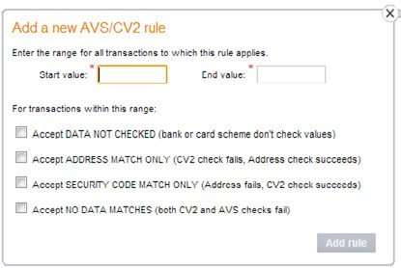

When setting your rules, you can have as many or as few as you would like. To set a rule all you need to do is pick a start price and end price range – anything from 0.00 – 100,000.00 and select what you would like to accept.

## 3D Secure

3D Secure is another fraud prevention tool that is available to you when using Sage Pay.

The 3D Secure scheme is managed by Verified by VISA and MasterCard Secure Code and is password protection for your shoppers.

If you have 3D Secure enabled on your account, your shoppers will be required to enter the password they have assigned to their card in order to process a transaction.

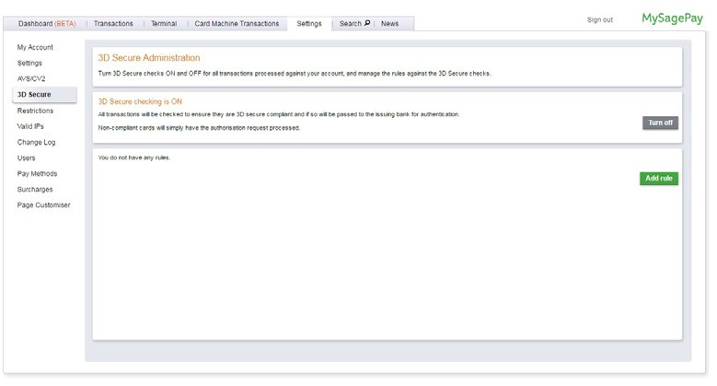

**Adding a rule**

Similar to the AVS/CV2 fraud prevention tools you are able to set your own rules that will define how Sage Pay use the results of the 3D Secure checks with your transactions.

You can decide when 3D Secure is applied to transactions, and if you would like the transactions to be accepted or rejected based on the 3D Secure results.

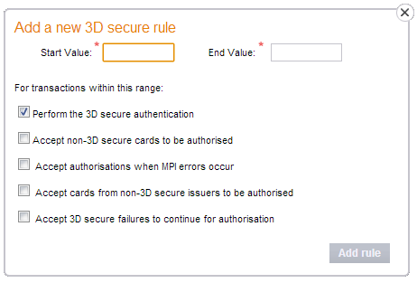

When adding a rule, you will need to select a start price and end price and what you would like to see accepted or rejected for each.

[If you would like to add a 3D Secure rule, full details on how to do so can be found here:](https://www.sagepay.co.uk/support/12/38/activating-adding-a-3d-secure-rule)

## Restrictions

The restrictions section is where you can manage IP addresses, countries, and cards you would like to prevent from processing transactions through your account.

There are four options to choose from when deciding what you would like to block.

**Blocked IP Addresses**

Here you can block specific or ranges of IP addresses from being able to process transactions through your account.

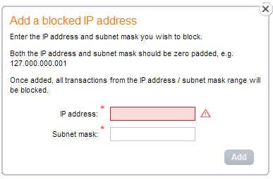

**Blocked Card Ranges**

By entering the first 9 digits of a specific card you will prevent any card beginning with those numbers from processing a transaction through your account.

[If you would like to know about blocking card ranges, please click here:](https://www.sagepay.co.uk/support/12/38/blocking-card-ranges)

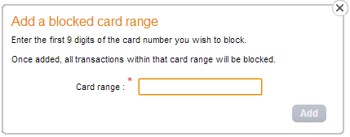

**Blocked Countries**

Blocking a country will stop any transactions from being accepted when the IP address used is from a country you have blocked.

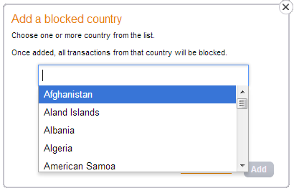

[To block a country you will need to select it](https://www.sagepay.co.uk/support/12/38/blocking-countries) from a list

**Blocked Issuing Countries**

By selecting to block a country you will prevent any cards that are issued in that country from being able to make a purchase through your account.

## Valid IPs

If you are using the Sage Pay Server or Direct method of integration you will need to submit a valid IP address for your application or website server to Sage Pay in order for your transactions to be accepted by our systems.

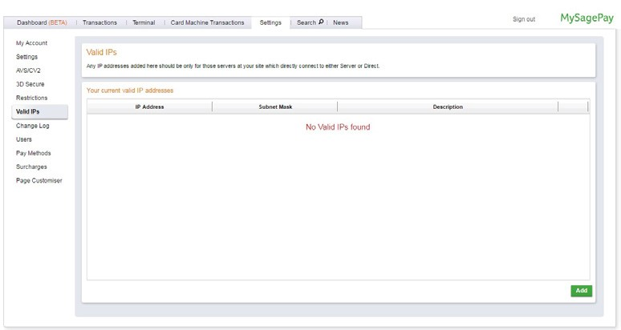

The Valid IP section allows you to manage the IP addresses of your website or applications that you would like Sage Pay to accept transactions from.

If a transaction request is received by Sage Pay from an IP address that is not on your valid list it will be rejected by [our system.](https://www.sagepay.co.uk/support/16/36/adding-an-ip-address-to-your-account)

[More information on adding IP addresses to your Sage Pay account can be found here:](https://www.sagepay.co.uk/support/16/36/adding-an-ip-address-to-your-account)

If you are using the Sage Pay virtual terminal to process transactions or the Form method of integration you will not need to use this section of MySagePay.

## Change Log

The change log provides a list of all of the changes that have been made to your MySagePay admin panel since you began using your account (these aren’t archived on a periodic basic like transactions). You will be shown changes to rules, restrictions, and users.

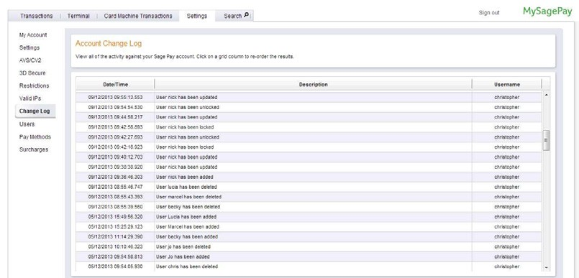

## Users

Here, you are able to manage all of the User profiles for your MySagePay. You are able to add and remove users, and change permissions of existing users in your account.

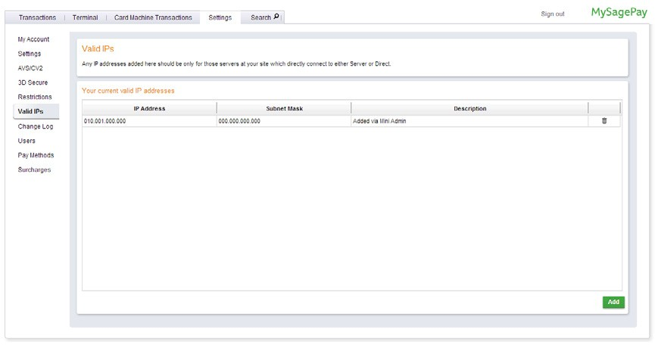

The main screen provides you with an overview of your users, you are then able to select any user to amend the details and permissions. By selecting the user, you want to amend you will be able to change all permissions for the user along with the passwords and email addresses assigned. You are also able to delete the users by selecting them.

Adding new users is also done here, by clicking New User you will be able to create new details

When adding users, or amending users any changes that you will make will appear in the change log so you can monitor the changes you have made.

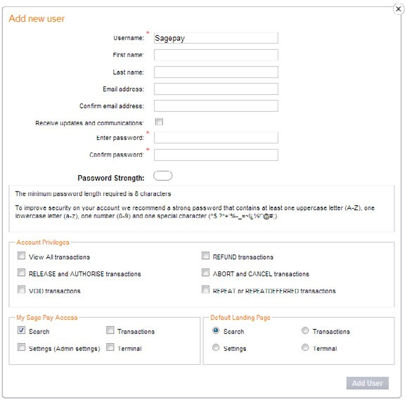

## 

## Pay Methods

The Pay Methods screen shows you all of the card types and currencies that can be accepted on your Sage Pay account.

If you would like to know what your account can accept you can select this page and all of the information will be displayed for you.

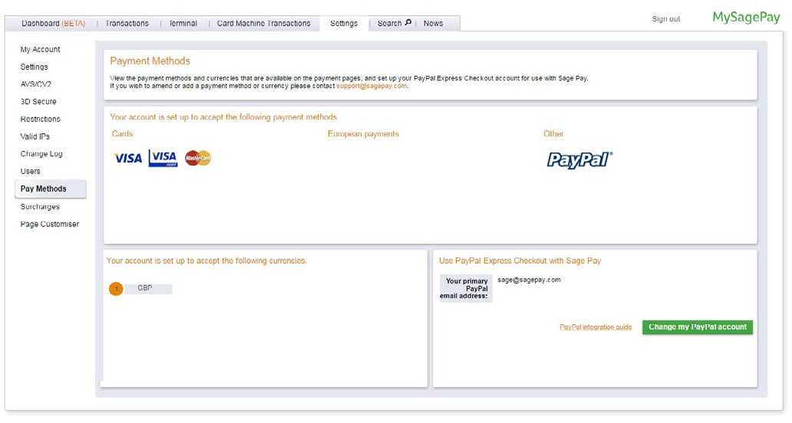

Along with the card types and currencies offered by your account you are also able to set-up your PayPal account to be used on your Sage Pay account here.

All you need to do within your MySagePay to set-up PayPal is click on the PayPal option in the bottom right hand of the screen and enter your PayPal e-mail address.

This will then link your PayPal account to the Sage Pay systems.

You will also need to make a number of changes to your PayPal account directly in order to enable it to be used with Sage Pay.

References

Paypal.com. (2018). *Send Money, Pay Online or Set Up a Merchant Account - PayPal*. [online] Available at: https://www.paypal.com/ie/webapps/mpp/home [Accessed 2 Apr. 2018].

Pay.amazon.com. (2018). *Securely Accept Payments Online | Amazon Pay*. [online] Available at: https://pay.amazon.com/uk [Accessed 2 Apr. 2018].

Sagepay.ie. (2018). *Simple, Flexible & Secure Payment Services with Sage Pay*. [online] Available at: https://www.sagepay.ie/ [Accessed 2 Apr. 2018].